Inattention/Patience

Overall
- Process the data according to actual question order based on baseline_order and order columns
- Visualize response times in multiple ways:
  - By question position (showing fatigue or learning effects)
  - By question type (baseline vs error threshold)
  - By theme (which topics take longer)
  - Individual participant patterns
  - Heatmap of theme × question type interactions
  - Order effect analysis
- Detect anomalies using multiple criteria:
  - Statistical outliers (z-scores > 3)
  - Too many extremely fast responses (< 3 seconds)
  - Too many extremely slow responses (> 120 seconds)
  - High inconsistency (coefficient of variation)
  - Unusual patterns (speeding up/slowing down)
- Theme-specific analysis comparing baseline vs error threshold times for each theme
The code identifies participants who might have:
- Rushed through questions without reading
- Gotten distracted during certain questions
- Shown fatigue effects
- Had technical issues
- Demonstrated inconsistent engagement

How Anomalous Participants are Detected:
The enhanced analysis detects anomalies through multiple layers:

1. Speed Patterns
- Speeding up: Negative slope in time trend, first half taking longer than second half
- Rushing: High proportion of ultra-fast responses (<2s), very low mean time
- Fatigue: Positive slope, slowing down over time
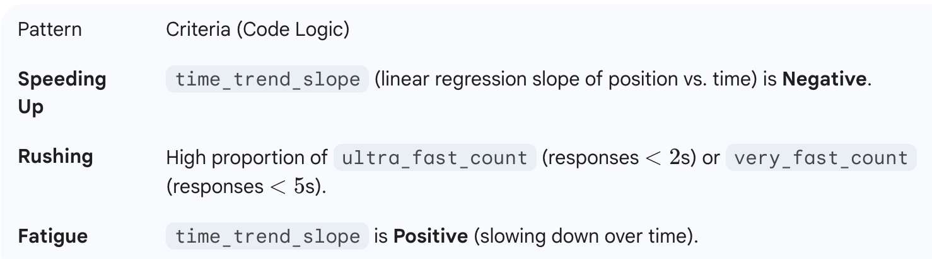

2. Consistency Metrics
- Coefficient of Variation (CV): High CV indicates inconsistent response patterns
- Quarter analysis: Comparing response times across survey quarters
- Range and IQR: Large ranges suggest attention lapses or technical issues
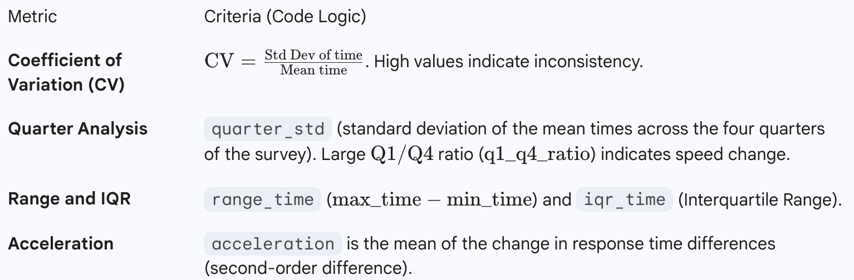

3. Suspicious Behaviors
- Ultra-fast streaks: Consecutive questions answered in <5 seconds
- Extreme proportions: Too many responses under 2 seconds
- Acceleration patterns: Sudden changes in response speed
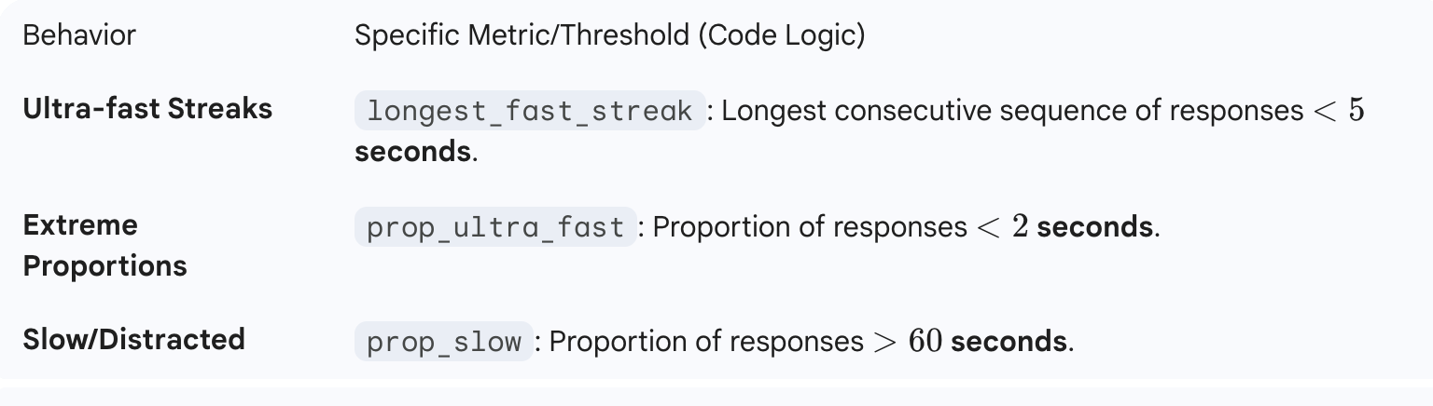

4. Composite Suspicion Score (0-100)
Combines multiple factors:
- Proportion of ultra-fast responses
- Degree of speeding up
- Response time inconsistency
- Overall mean time
- Length of fast response streaks
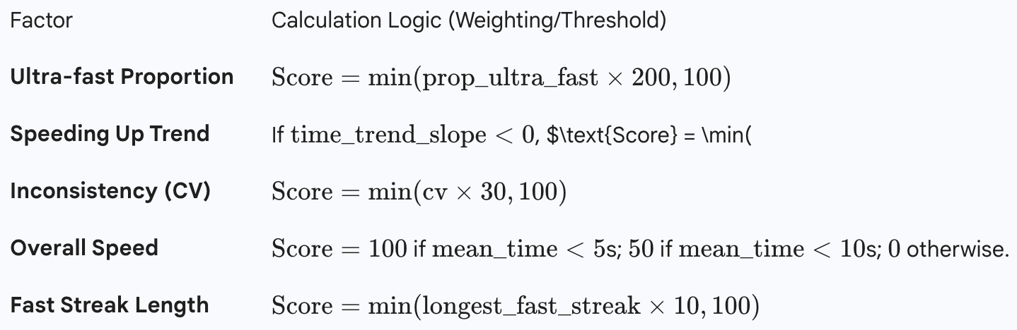

5. Pattern Classification (Boolean)
- Speeder: Accelerates through survey
- Rusher: Consistently too fast
- Careful: Takes time to read/think
- Inconsistent: Erratic timing patterns
- Fatigue: Slows down over time
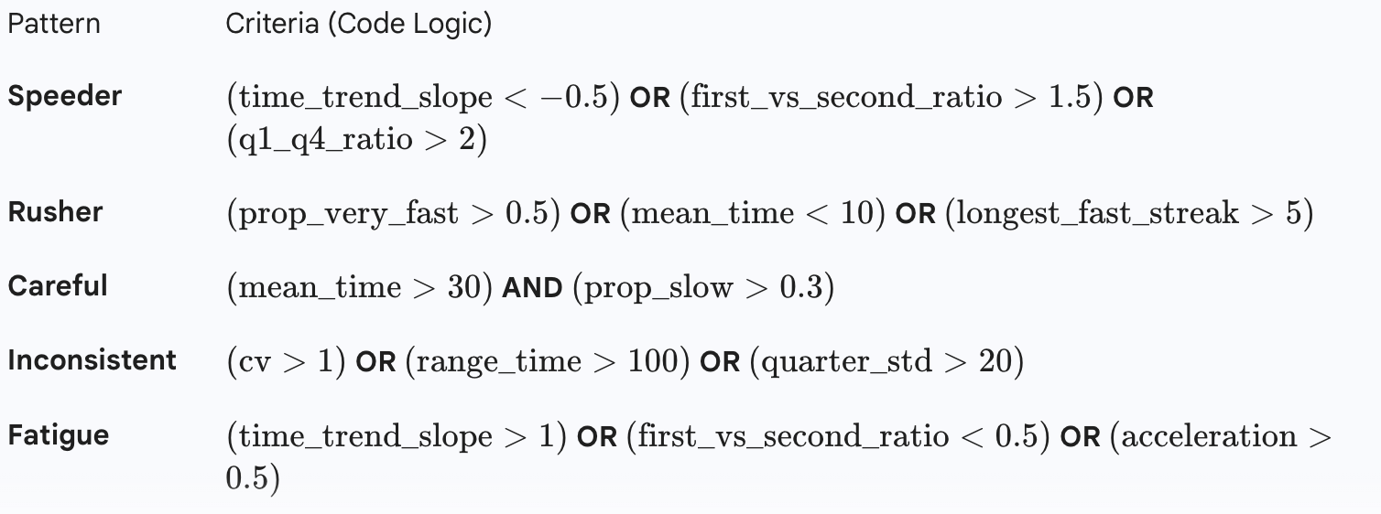

6. Clustering Analysis
Groups participants with similar behaviors to identify:
- Normal responders
- Speed optimizers
- Distracted responders
- Potential bots/automated responses
The Clustering Analysis uses K-Means on a standardized feature set to group participants. The specific categorization requires manual inspection and mapping of the resulting numerical clusters to the descriptive names:
The features used for clustering are:
- mean_time
- cv (Coefficient of Variation)
- time_trend_slope
- prop_very_fast
- prop_slow
- first_vs_second_ratio
- longest_fast_streak
The mapping logic based on expected cluster characteristics (as described in the added categorization code):
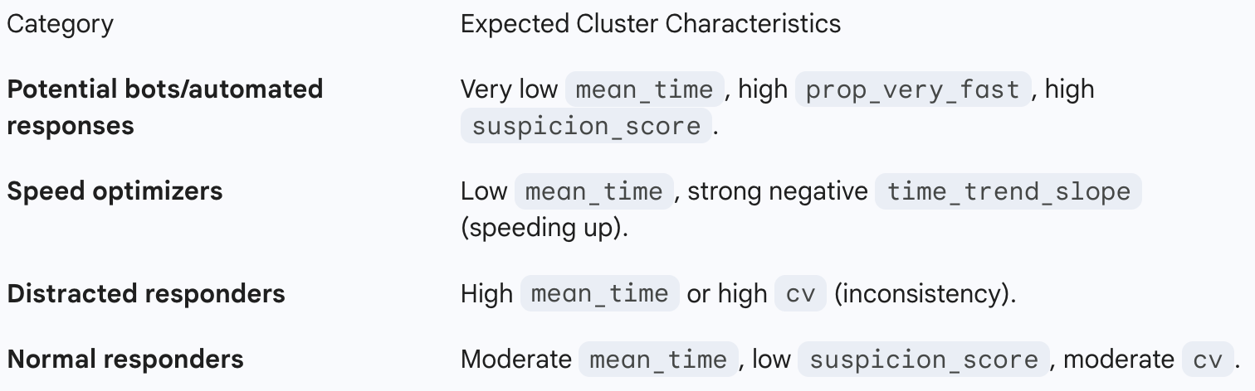

REFERENCES FOR SURVEY QUALITY DETECTION METHODS

1. SPEEDING AND RUSHING DETECTION
Zhang, C., & Conrad, F. G. (2014). "Speeding in web surveys: The tendency to answer
very fast and its association with straightlining." Survey Research Methods, 8(2), 127-135.
- Establishes 2 seconds per question as ultra-fast threshold
- Links speeding to poor data quality

Greszki, R., Meyer, M., & Schoen, H. (2015). "Exploring the effects of removing
'too fast' responses and respondents from web surveys." Public Opinion Quarterly, 79(2), 471-503.
- Recommends page timing thresholds
- Shows 2-3 seconds minimum for simple questions

2. RESPONSE PATTERN ANALYSIS
Kemper, C. J., & Menold, N. (2014). "Nuisance or remedy? The utility of stylistic
responding as an indicator of data fabrication in surveys." Methodology, 10(3), 92-99.
- Coefficient of variation as consistency measure
- Pattern detection for fabricated data

Curran, P. G. (2016). "Methods for the detection of carelessly invalid responses in
survey data." Journal of Experimental Social Psychology, 66, 4-19.
https://doi.org/10.1016/j.jesp.2015.07.006
- Comprehensive review of detection methods
- Includes: response time, consistency indices, Mahalanobis distance

3. ATTENTION CHECK MECHANISMS
Meade, A. W., & Craig, S. B. (2012). "Identifying careless responses in survey data."
Psychological Methods, 17(3), 437-455.
https://doi.org/10.1037/a0028085
- Gold standard for attention check design
- Multiple detection indices including response time

Abbey, J. D., & Meloy, M. G. (2017). "Attention by design: Using attention checks to
detect inattentive respondents and improve data quality." Journal of Operations Management, 53, 63-70.
- Temporal patterns in survey responses
- Combining multiple indicators

4. CLUSTERING & CLASSIFICATION
Blasius, J., & Thiessen, V. (2015). "Should we trust survey data? Assessing response
simplification and data fabrication." Social Science Research, 52, 479-493.
- Cluster analysis for respondent types
- Identifying satisficing behaviors

Leiner, D. J. (2019). "Too fast, too straight, too weird: Non-reactive indicators for
meaningless data in internet surveys." Survey Research Methods, 13(3), 229-248.
https://doi.org/10.18148/srm/2019.v13i3.7403
- "Too fast" criteria and thresholds
- Multivariate detection approaches

5. SATISFICING & RESPONSE QUALITY
Krosnick, J. A. (1991). "Response strategies for coping with the cognitive demands of
attitude measures in surveys." Applied Cognitive Psychology, 5(3), 213-236.
- Theoretical foundation for satisficing
- Framework for understanding rushed responses

Hamby, T., & Taylor, W. (2016). "Survey satisficing inflates reliability and validity
measures: An experimental comparison of college and Amazon Mechanical Turk samples."
Educational and Psychological Measurement, 76(6), 912-932.
- Impact of satisficing on data quality
- Detection through response patterns

6. STATISTICAL METHODS
Niessen, A. S. M., Meijer, R. R., & Tendeiro, J. N. (2016). "Detecting careless
respondents in web-based questionnaires: Which method to use?" Journal of Research in Personality, 63, 1-11.
- Comparison of detection methods
- Mahalanobis distance, response consistency

DeSimone, J. A., & Harms, P. D. (2018). "Dirty data: The effects of screening
respondents who provide low-quality data in survey research." Journal of Business and Psychology, 33(5), 559-577.
- Impact of removing flagged responses
- Multiple screening criteria

7. SDT-SPECIFIC SURVEY METHODOLOGY
Green, D. M., & Swets, J. A. (1966). Signal Detection Theory and Psychophysics. Wiley.
- Foundation for error threshold questions
- Framework for baseline rate considerations

Stanislaw, H., & Todorov, N. (1999). "Calculation of signal detection theory measures."
Behavior Research Methods, 31(1), 137-149.
- SDT application in behavioral research
- Response bias considerations

